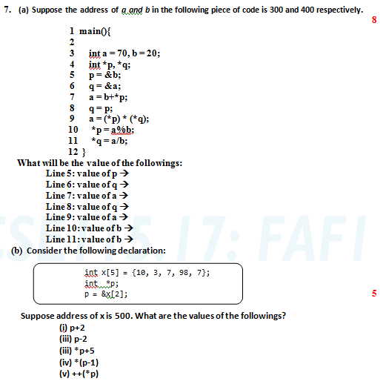

Solution of a :

Line 5: value of p 🡪 400

Line 6: value of q 🡪 300

Line 7: value of a 🡪 40

Line 8: value of q 🡪 400

Line 9: value of a 🡪 400

Line 10: value of b 🡪 0

Line 11: value of b 🡪 infinity

Solution of b :

1. P+2 = 516
2. P-2 = 500
3. \*(p+5) = 12
4. \*(p-1) = 3
5. ++(\*p) = 7